Jenkins agents Pod installation on Control plane to avoid it launching on any node used
Here node affinity and toleration to match host in control-plane role
Prerequisite for local machine for persistent storage and node affinity in control plane
Raw disk attach to vm /dev/sdb 10g
#fdisk /dev/sdb
Press n for new partition ,press enter for first size as starting size blank
Press last size +5G ,press t for types of filesystem ,press L for list those types
Press 83 for linux filesystem ,press w for write
#mkfs.ext4 /dev/sdb1
To apply ext4 filesystem
#mkdir –p /mnt/disks/jenkins-agent
#vi /etc/fstab
/dev/sdb1 /mnt/disks/jenkins-agent ext4 defaults 0 0
:wq!

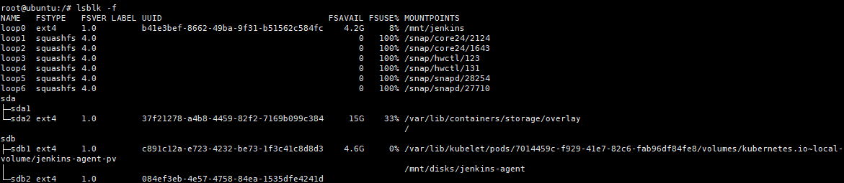
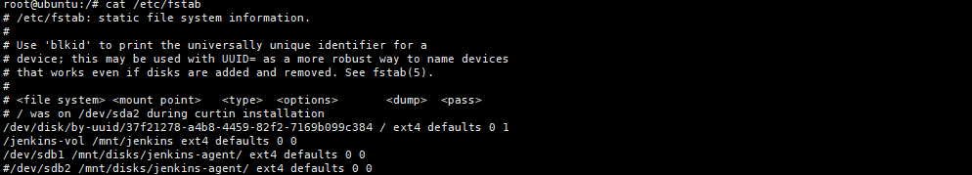

#vi jenkins-agent-with-affinity-toleration-pvc.yaml

Check all fields like mathing of pv and pvc size .it should be lower than actual mount point
Of raw disk
Check node affinity and taint tolerations for pod
Here two containers are run
Sidecar container: dind Docker in Docker
Main container: Jenkins-agent

#cat jenkins-agent-with-affinity-toleration-pvc.yaml
apiVersion: storage.k8s.io/v1
kind: StorageClass
metadata:
name: local-ubuntu-storageclass
provisioner: kubernetes.io/no-provisioner
volumeBindingMode: WaitForFirstConsumer
---
apiVersion: v1
kind: PersistentVolume
metadata:
name: jenkins-agent-pv
spec:
capacity:
storage: 4.5G
volumeMode: Filesystem
accessModes:
- ReadWriteOnce
persistentVolumeReclaimPolicy: Retain
storageClassName: local-ubuntu-storageclass
local:
path: /mnt/disks/jenkins-agent
nodeAffinity:
required:
nodeSelectorTerms:
- matchExpressions:
- key: kubernetes.io/hostname
operator: In
values:
- ubuntu
---
apiVersion: v1
kind: PersistentVolumeClaim
metadata:
name: jenkins-agent-pvc
spec:
accessModes:
- ReadWriteOnce
storageClassName: local-ubuntu-storageclass
resources:
requests:
storage: 4.5G
---
apiVersion: v1
kind: Pod
metadata:
name: jenkins-agent
labels:
role: jenkins-agent
spec:
# Hostname affinity to target 'ubuntu' node
affinity:
nodeAffinity:
requiredDuringSchedulingIgnoredDuringExecution:
nodeSelectorTerms:
- matchExpressions:
- key: kubernetes.io/hostname
operator: In
values:
- ubuntu

# Tolerations for control plane taints
tolerations:
- key: "node-role.kubernetes.io/control-plane"
operator: "Exists"
effect: "NoSchedule"

containers:
# 1. The SSH Agent Server
- name: jenkins-ssh-agent
image: jenkins/ssh-agent:alpine-jdk21
command: ["/bin/sh", "-c"]
args:
- |
# 1. Install packages
apk add --no-cache docker-cli kubectl

# 2. Configure SSH securely without blocking execution
echo "jenkins:root" | chpasswd
sed "-i" 's/^#\?PasswordAuthentication.*/PasswordAuthentication yes/' /etc/ssh/sshd_config
sed "-i" 's/^#\?PubkeyAuthentication.*/PubkeyAuthentication no/' /etc/ssh/sshd_config

# 3. Hand over control to the official entrypoint script
exec /usr/local/bin/setup-sshd
ports:
- containerPort: 22
name: ssh
securityContext:
capabilities:
add:
- SYS_CHROOT
env:
- name: DOCKER_HOST
value: tcp://localhost:2376
- name: DOCKER_TLS_VERIFY
value: "1"
- name: DOCKER_CERT_PATH
value: /certs/client
volumeMounts:
- name: dind-certs
mountPath: /certs
- name: shared-workspace
mountPath: /home/jenkins/agent

# 2. The Separate, Standalone Docker Engine
- name: dind-daemon
image: docker:27-dind
securityContext:
privileged: true
env:
- name: DOCKER_TLS_CERTDIR
value: /certs
volumeMounts:
- name: dind-certs
mountPath: /certs
- name: shared-workspace
mountPath: /home/jenkins/agent

volumes:
- name: dind-certs
emptyDir: {}
- name: shared-workspace
persistentVolumeClaim:
claimName: jenkins-agent-pvc

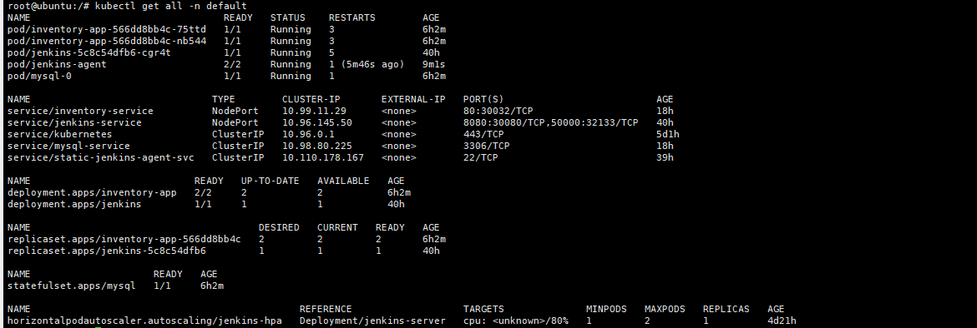
Check Jenkins-agent pod logs
Kubectl logs –f jenkins-agent
Kubectl logs jenkins-agent
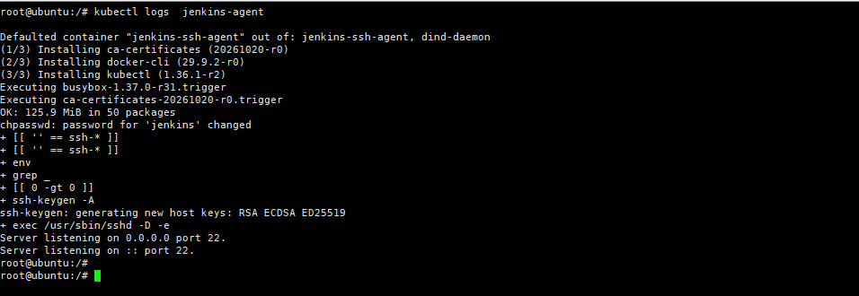
Logs shows agent is ready and listening on port 22 SSH
All required packages for jenkins-agent to build docker images and run kubectl for deploying pods is installed

Adding jenkins slave to jenkins master
Manage Jenkins – Credentials
Check the service endpoint of Jenkins-agent-service
# kubectl get endpoints static-jenkins-agent-svc
Add this ip in Jenkins master in node configure
Add username password
Username Jenkins
Password root
Add label as jenkins-agent

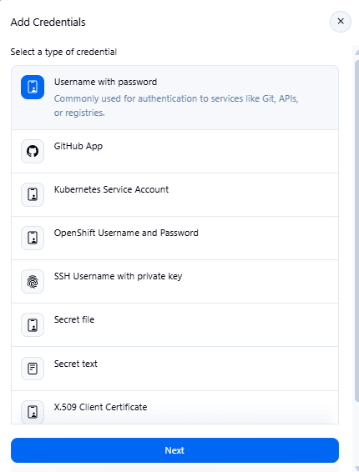

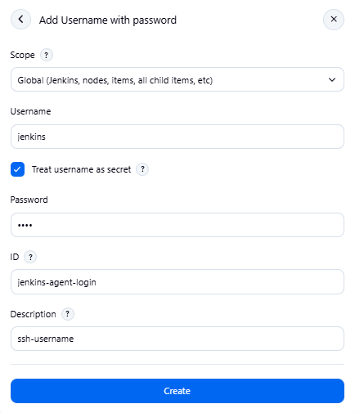
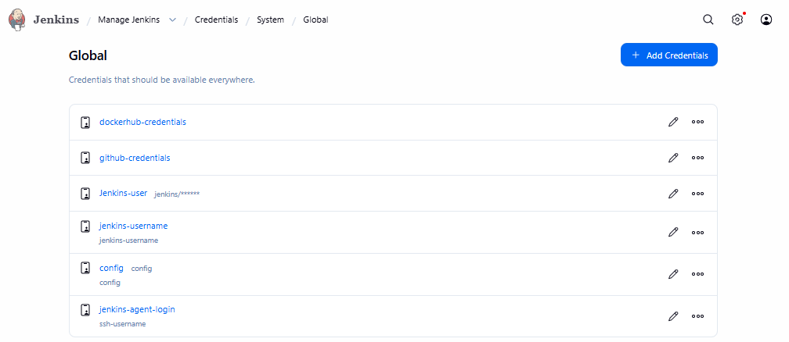

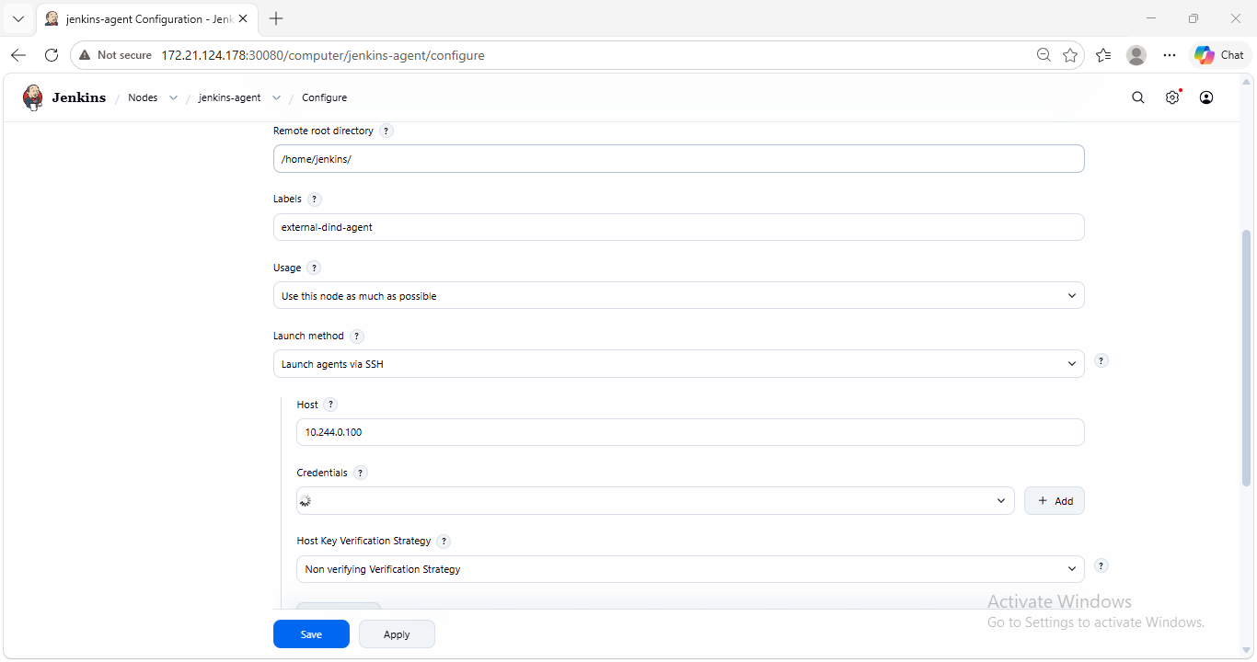
Run the Jenkins launch agent
If find issue is logs ,relaunch after disconnect agent
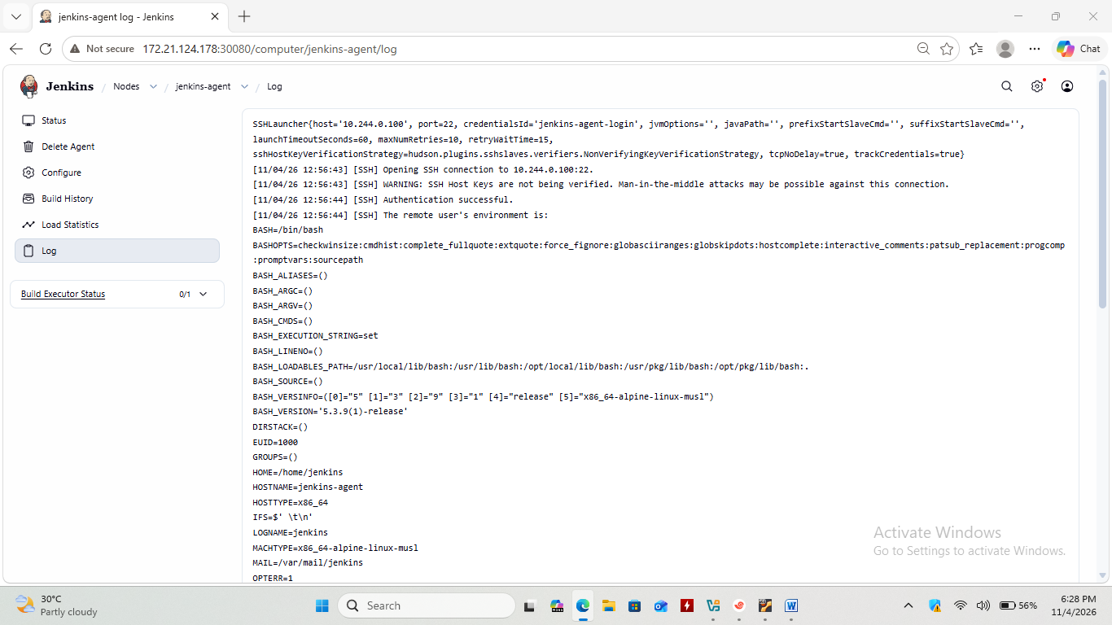

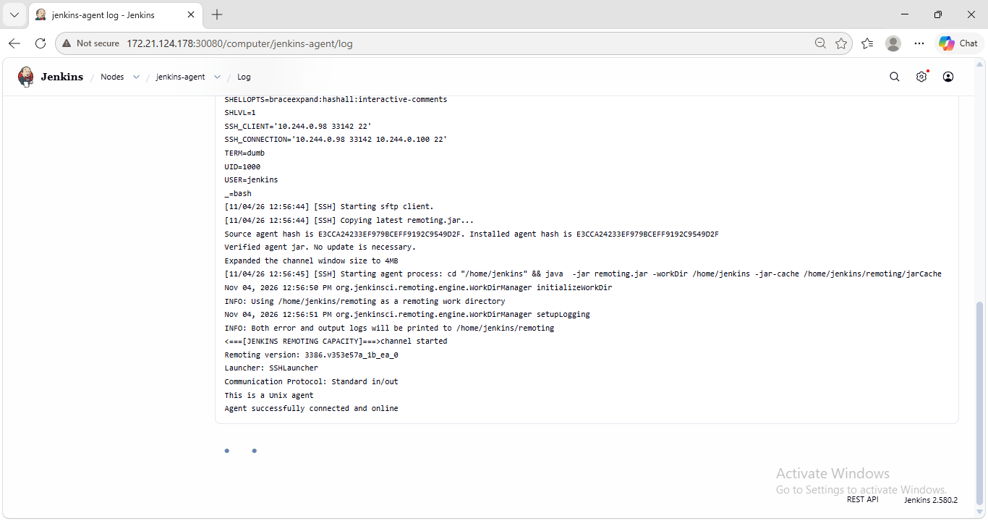

To avoid launch of selection of buit-in agent of Jenkins master
Label the master
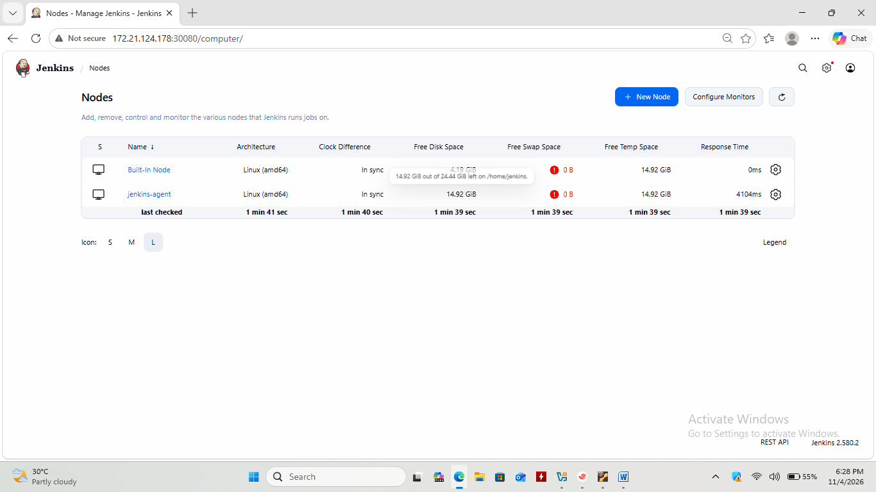
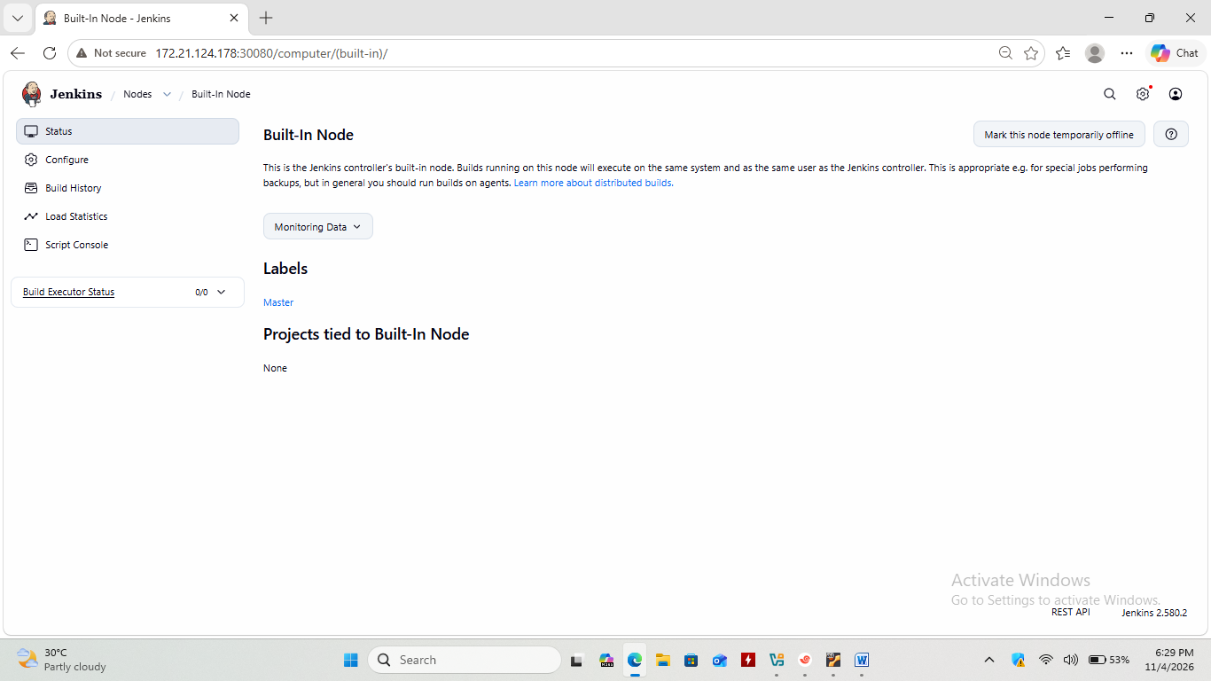
Login to jenkins-agent pod from kubermetes master
Create .kube directory
Create a config file in .kube
touch config
vi config ---
add the key content from kubernetes master of kubeadm setup
key path ~/.kube/config
copy the content and paste in pod
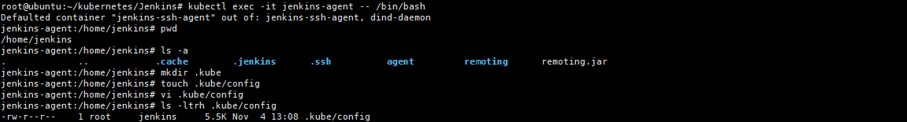

Now goto Jenkins master and launch project pipeline
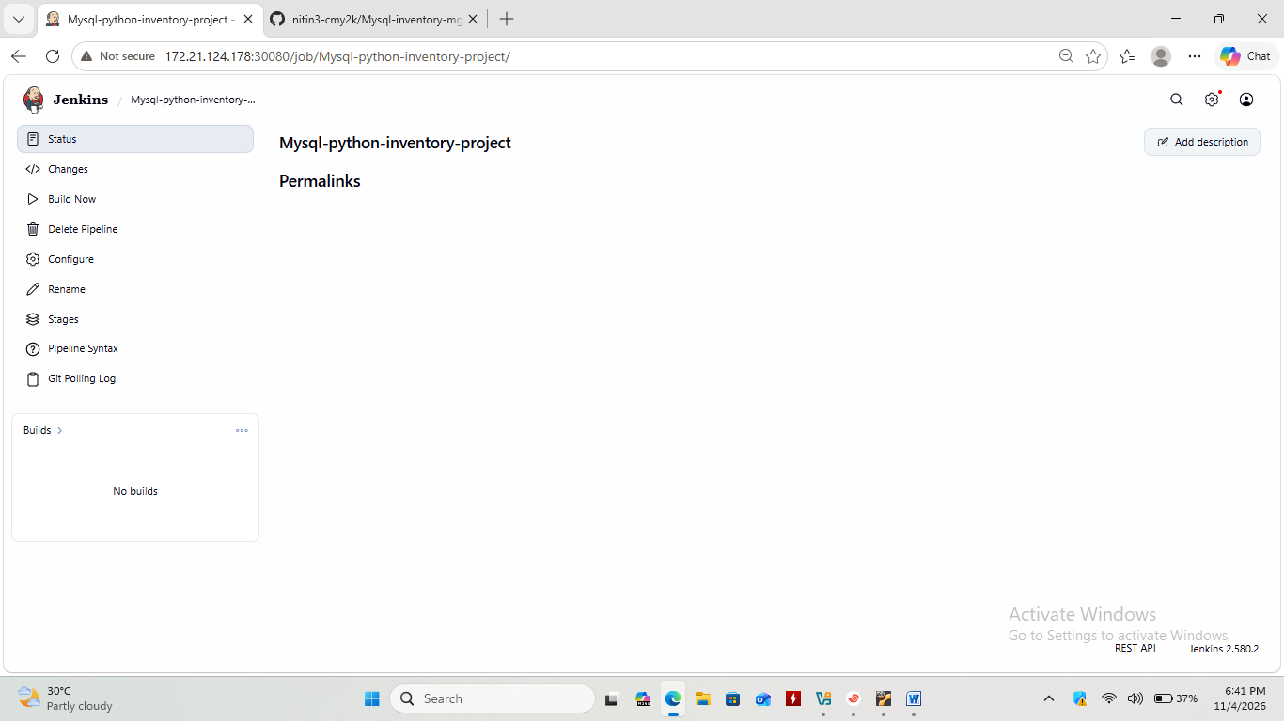

Note after machine restart or agent-pod recreated check service endpoint IP
And modify it in Jenkins master node configure to allow ssh to newly started agent pod

